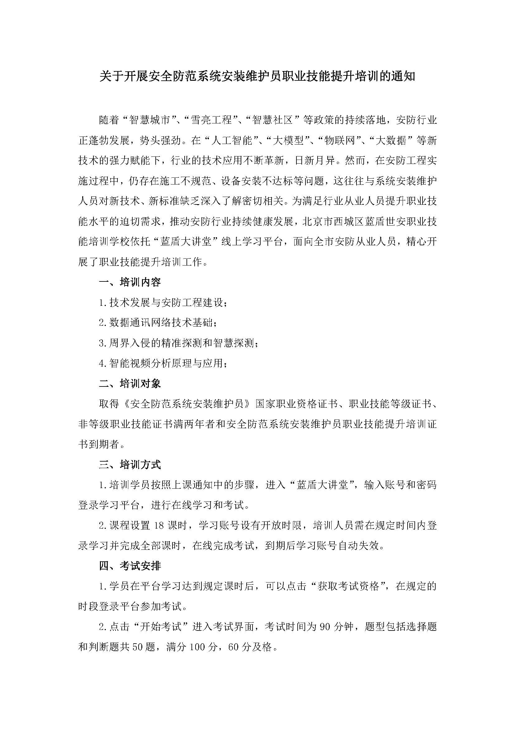

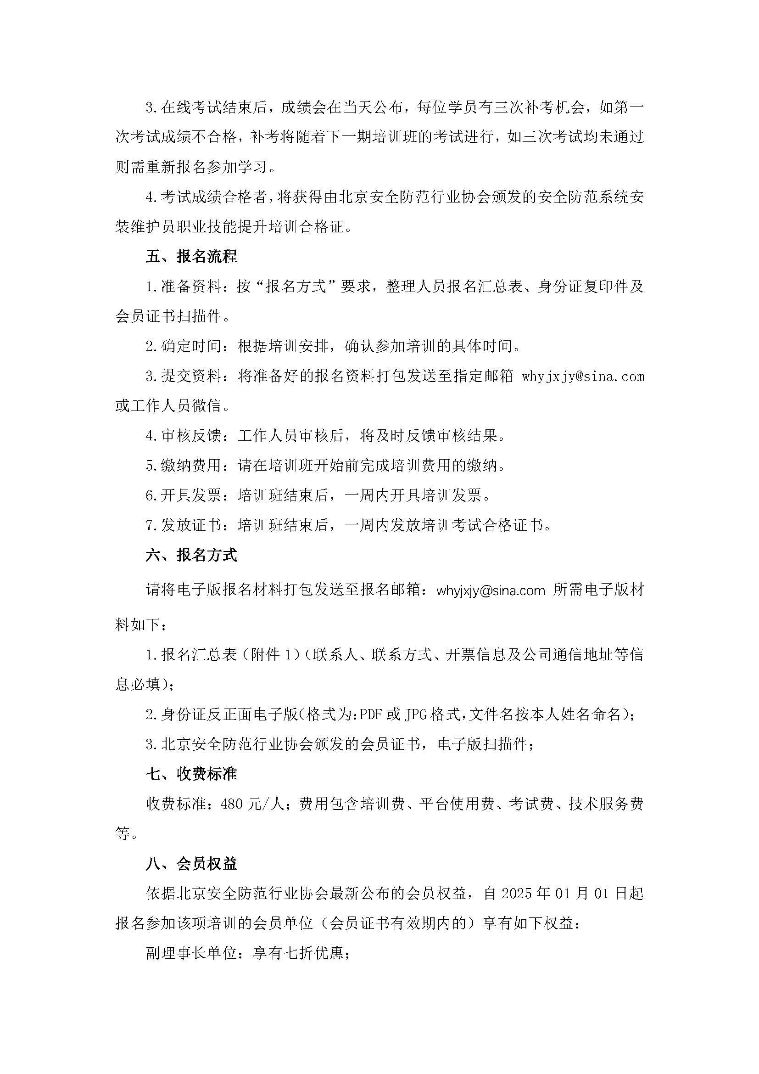

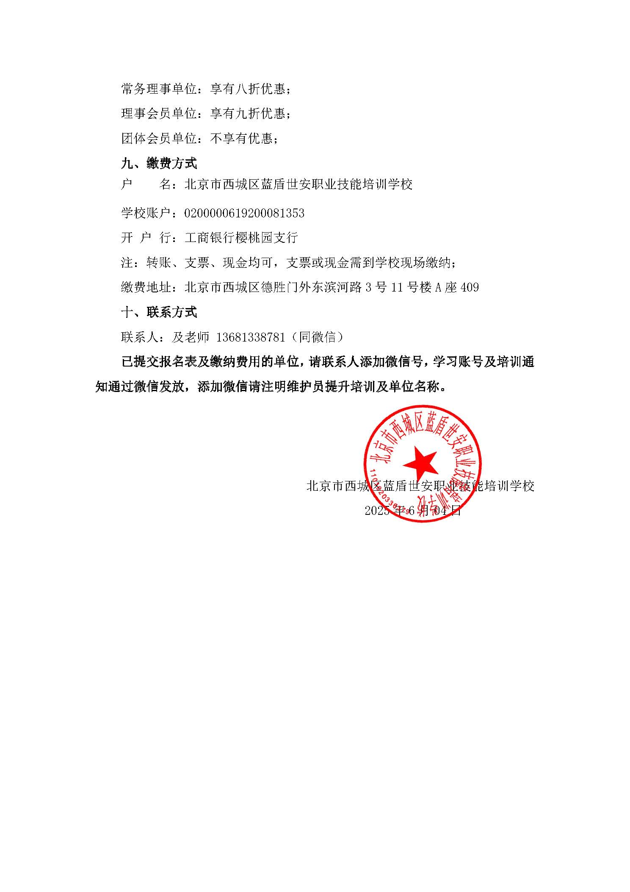

**附件1：报名汇总表**

|  |  |  |  |  |  |  |  |
| --- | --- | --- | --- | --- | --- | --- | --- |
| **安全防范系统安装维护员职业技能提升培训报名汇总表** | | | | | | | |
| **单位名称** |  | | | **发票类型** | **增值税普通发票：（ ）**  **增值税专用发票：（ ）** | | |
| **收件地址** |  | | | **开票信息**  **具体相关信息，请咨询贵司财务人员** | **发票抬头：**  **纳税人识别号：**  **开户银行：**  **银行账号：**  **注册地址：**  **电话：** | | |
| **联系人** |  | **手机** |  |
| **QQ** |  |
| **E-mail** |  | | |
| **序号** | **姓名** | **性别** | **身份证号** | | **证书类型** | **证书编号** | **手机** |
| 1 |  |  |  | |  |  |  |
| 2 |  |  |  | |  |  |  |
| 3 |  |  |  | |  |  |  |
| 4 |  |  |  | |  |  |  |
| 5 |  |  |  | |  |  |  |
| 6 |  |  |  | |  |  |  |
| 7 |  |  |  | |  |  |  |
| 8 |  |  |  | |  |  |  |
| 9 |  |  |  | |  |  |  |
| 10 |  |  |  | |  |  |  |
| 11 |  |  |  | |  |  |  |
| 12 |  |  |  | |  |  |  |
| 13 |  |  |  | |  |  |  |
| 14 |  |  |  | |  |  |  |
|  | 注：本表为报名人员统计表，填写完成后请把本表及报名资料发送到指定邮箱whyjxjy@sina.com。  联系人：及老师13681338781（同微信） | | | | | | |